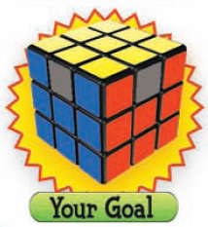
Step #6
Make your Rubik’s Cube look like the following image.
Tips:
- If you have two of the corner pieces in the right spot then put them n the back of your Cube and do the following steps.
- If you DO NOT have two corners in the right spot then do the following step until you have two corners in the correct position.
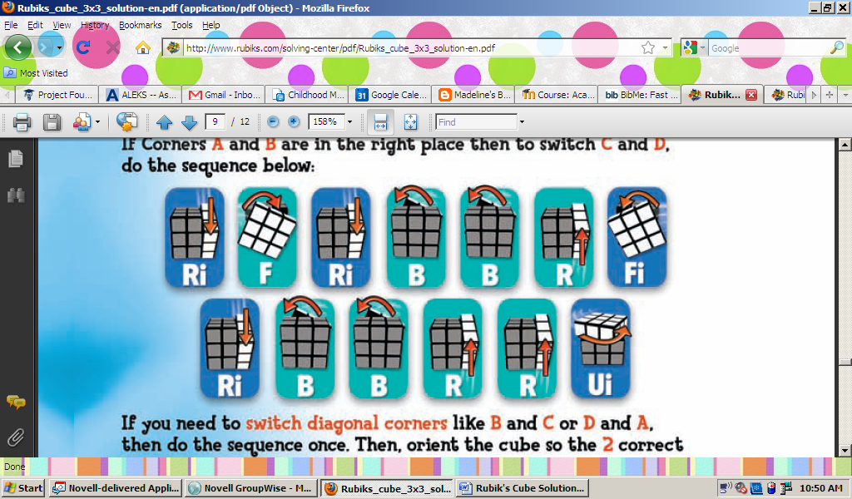

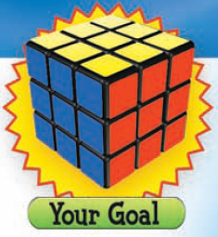
Step #7
Make your Rubik’s Cube look like the following image.
Tips:
- Look at your Rubik’s cube.
- See which way the top-middle pieces have to go: Clockwise or Counter-clockwise
- Make sure you put the finished side in the back

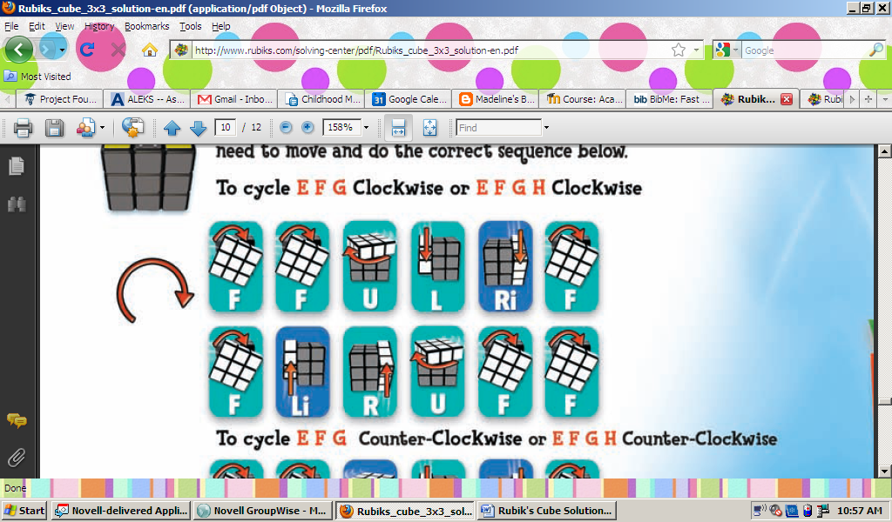
This is the CLOCKWISE formula

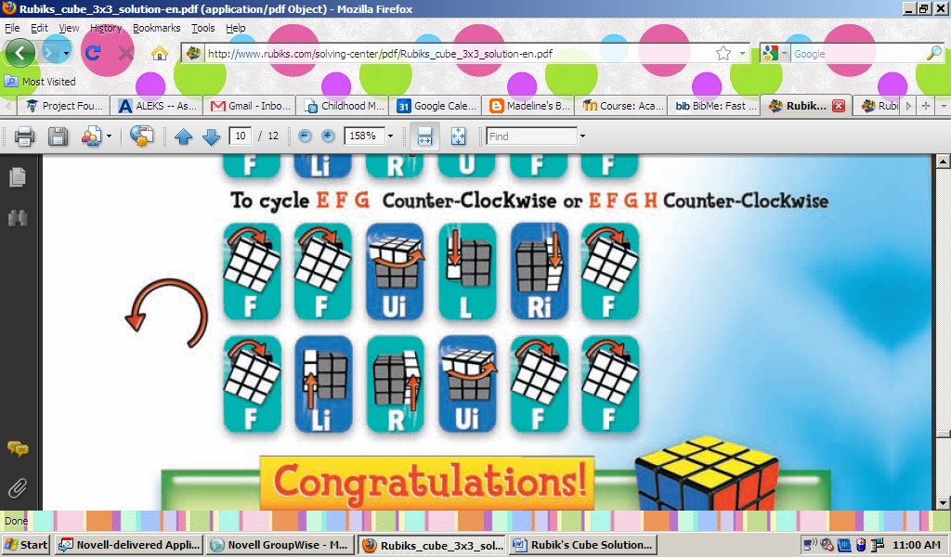
This is the COUNTER-CLOCKWISE formula

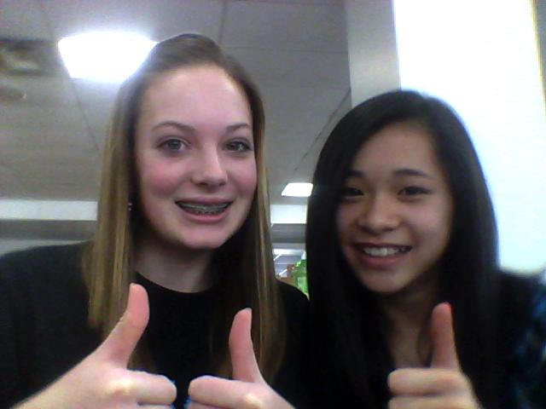
CONGRADULATIONS! You have finished a Rubik’s cube.

