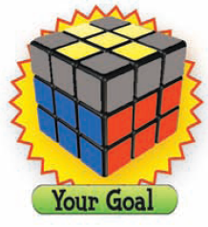
Step #4
Make you Rubik’s Cube look like the following image.
Tips:
- Match your Rubik’s Cube to one of the following images and do the steps that follow.
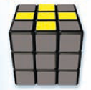
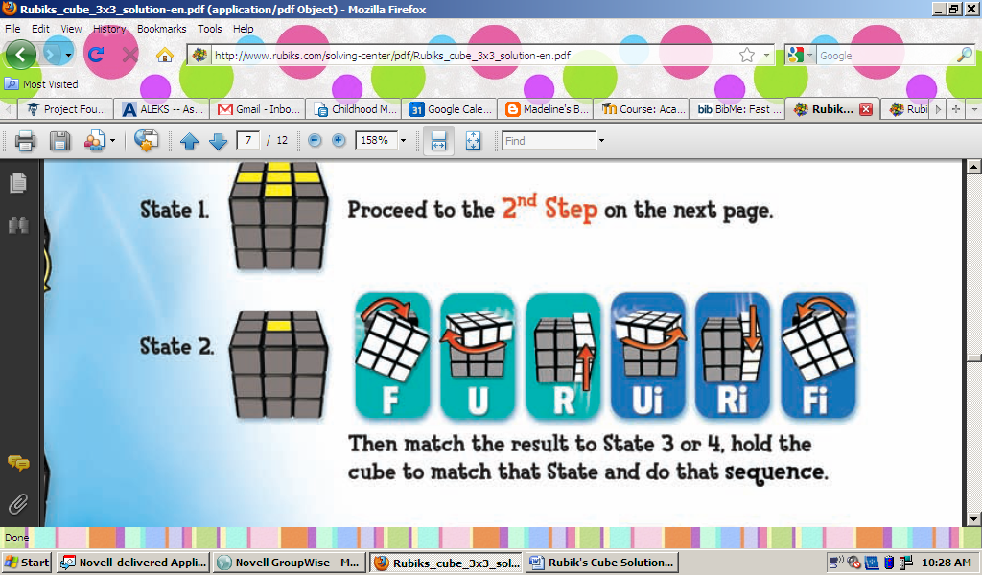
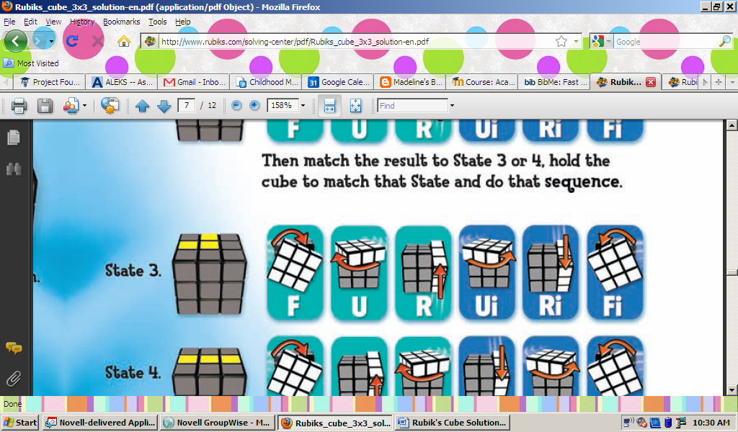
Proceed to the next step.

Then match the result of this step to either of the following

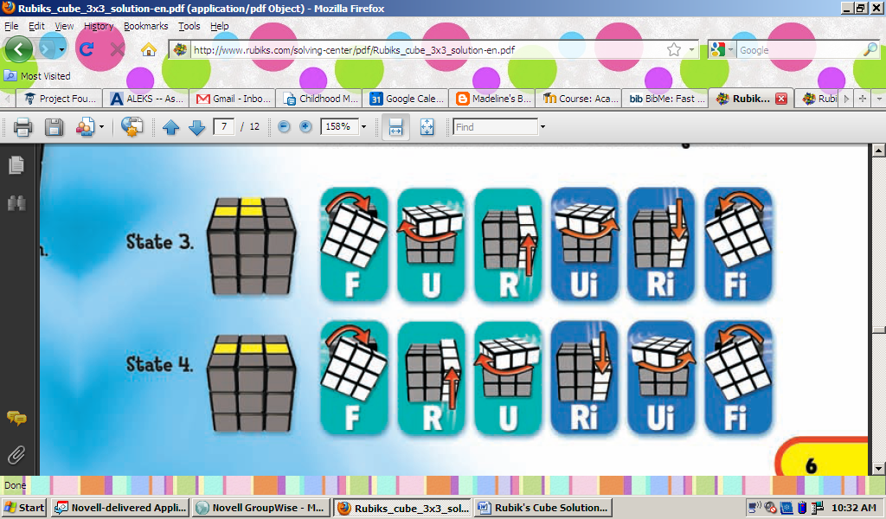

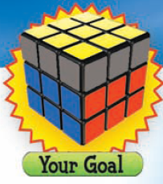
Step #5
Make your Rubik’s Cube look like the following image.
Tips:
- Match your Rubik’s Cube to one of the following images and the steps that follow


