How to Solve a Rubik’s Cube in 7 Easy Steps

Get to know your Rubik’s Cube
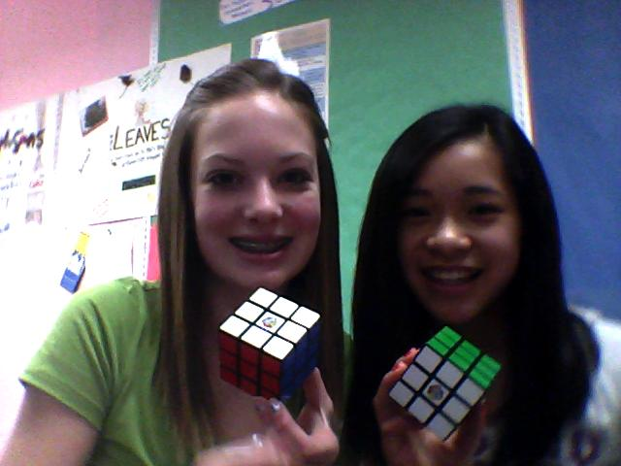
- There are six centers with one color on each -- the centers never move.
- Center piece colors are always opposite each other.
- white and yellow
- red and orange
- green and blue
- There are twelve edge pieces with two colors on each of them.
- There are eight corner pieces with three colors on each of them.

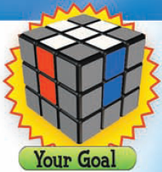

Step #1
Make your Rubik’s Cube look like the following image.
Tips:
- The edge colors match the white center and the side center which is either red, blue, orange, or green.
- Find the Blue/White piece and rotate it unit it is on the bottom side opposite the white side.
- Then rotate it until it is on the top and repeat that for the other pieces.

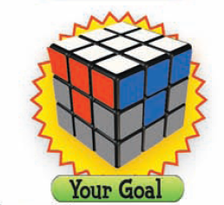
Step #2
Make you Rubik’s Cube look like the following image.
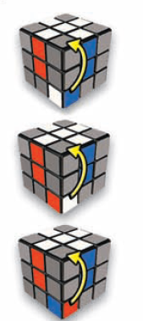
Tips:
- If you Rubik’s Cube looks like any of the following do this step 1-3 times until you Rubik’s Cube looks like the image above.
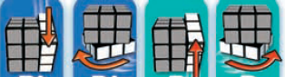

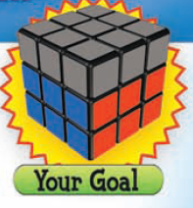

Step #3
Make your Rubik’s Cube look like following image.
Tips:
- Hold your Rubik’s Cube with the white side down.
- Then spin the top until it looks like either of the following images and do the steps that follow them.


